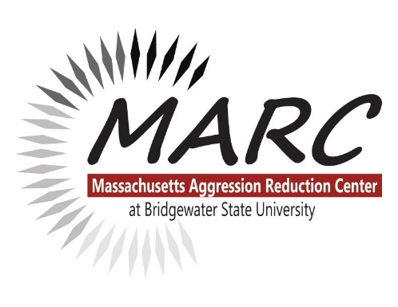
About us:
The Massachusetts Aggression Reduction Center provides free and low-cost bullying and cyberbullying prevention research and resources to schools, families, and professionals, in the United States and beyond. MARC is an academic Center at Bridgewater State University staffed by faculty, students, office staff and many wonderful volunteers. We offer free curricula, training and presentations for children; training for educators and professionals; and presentations and resources for parents and families. Devoted to violence prevention since 2004.

Train the Trainer Webinars:
Participants will be trained and certified by MARC to educate their colleagues in bullying and cyberbullying prevention*. Professional educators who complete this training are authorized to use MARC materials and data disseminated in this workshop. This program is intended and tested for use with professional teachers and other educational staff, faculty and administrators in K-12 schools. The cost for the 3 hour webinar includes materials, one year access to digital materials, and a PDP certificate (upon request). Registration is required in order to attend. Visit https://www.marccenter.org/training-events for our current list of webinar dates and registration form.
*Topics in the training have been updated to include research on the impact of the current pandemic, and an important focus on bias and diversity.
Agenda:
8:50 a.m. – 9:00 a.m. Early sign in recommended
9:00 a.m. (start) – 9:15 a.m. Welcome (co-sponsoring District Attorney when applicable)
9:15 a.m. – 12:00 p.m. Anti-bullying presentation (MARC Founder and Executive Director Elizabeth Englander)

