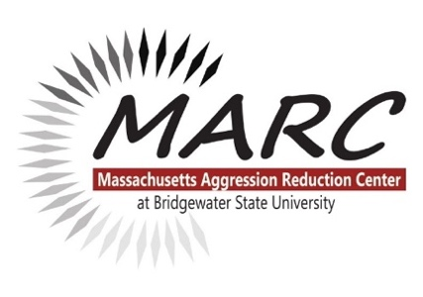

About us:
The Massachusetts Aggression Reduction Center provides free and low-cost bullying and cyberbullying prevention research and resources to schools, families, and professionals, in the United States and beyond. MARC is an academic Center at Bridgewater State University staffed by faculty, students, office staff and many wonderful volunteers. We offer free curricula, training and presentations for children; training for educators and professionals; and presentations and resources for parents and families. Devoted to violence prevention since 2004.

Train the Trainer Program:
Participants will be trained and certified by MARC to educate their colleagues in bullying and cyberbullying prevention. Topics in the training have been updated to include research on the impact of the current pandemic, and an important focus on bias and diversity. Professional educators who complete this training are authorized to use MARC materials and data disseminated in this workshop. This program is intended and tested for use with professional teachers and other educational staff, faculty and administrators in K-12 schools. The cost for the training includes materials, one year access to digital materials, and a PDP certificate (upon request). Registration is required in order to participate. Visit https://www.marccenter.org/training-events for our current list of in-person or live webinar dates as well as our Online version and the appropriate registration forms.

Payment Information:
Our registration forms offer 2 options: Pay by Credit Card and Invoicing/Purchase Order use.
- If credit card is selected a link will be emailed to the person filling out the form. Visa/Mastercard accepted Electronic check payments (ACH) require a bank routing number and account number. Payments can be made from a personal checking or savings account. No corporate checks allowed, i.e. credit cards, home equity, traveler's checks, etc.
- If invoicing is selected an invoice will be emailed to the billing email address given on the form after live Workshop dates. With the Online version: Invoices are sent within approximately 5 business days of registration form submissions. Once payment or PO information is received, training materials will be sent to Trainee(s). Finished Purchase Orders should be sent to mduphily@bridgew.edu (Fax 508-531-5784).
Checks should be made out to Bridgewater State University and mailed to: Bridgewater State University, Attention: Melissa Howarth, 131 Summer Street, Boyden #109, Bridgewater, MA 02325.
*You must enter your MARC invoice number to check memo or payment may not apply towards your invoice (It will start with MARC-followed by a 4 digit number). When in doubt send a copy of the invoice with the check just in case!

Questions? We accommodate billing requests whenever possible! Email mduphily@bridgew.edu

